**Task – 14**

**Creating a VPC with internet gateway:**

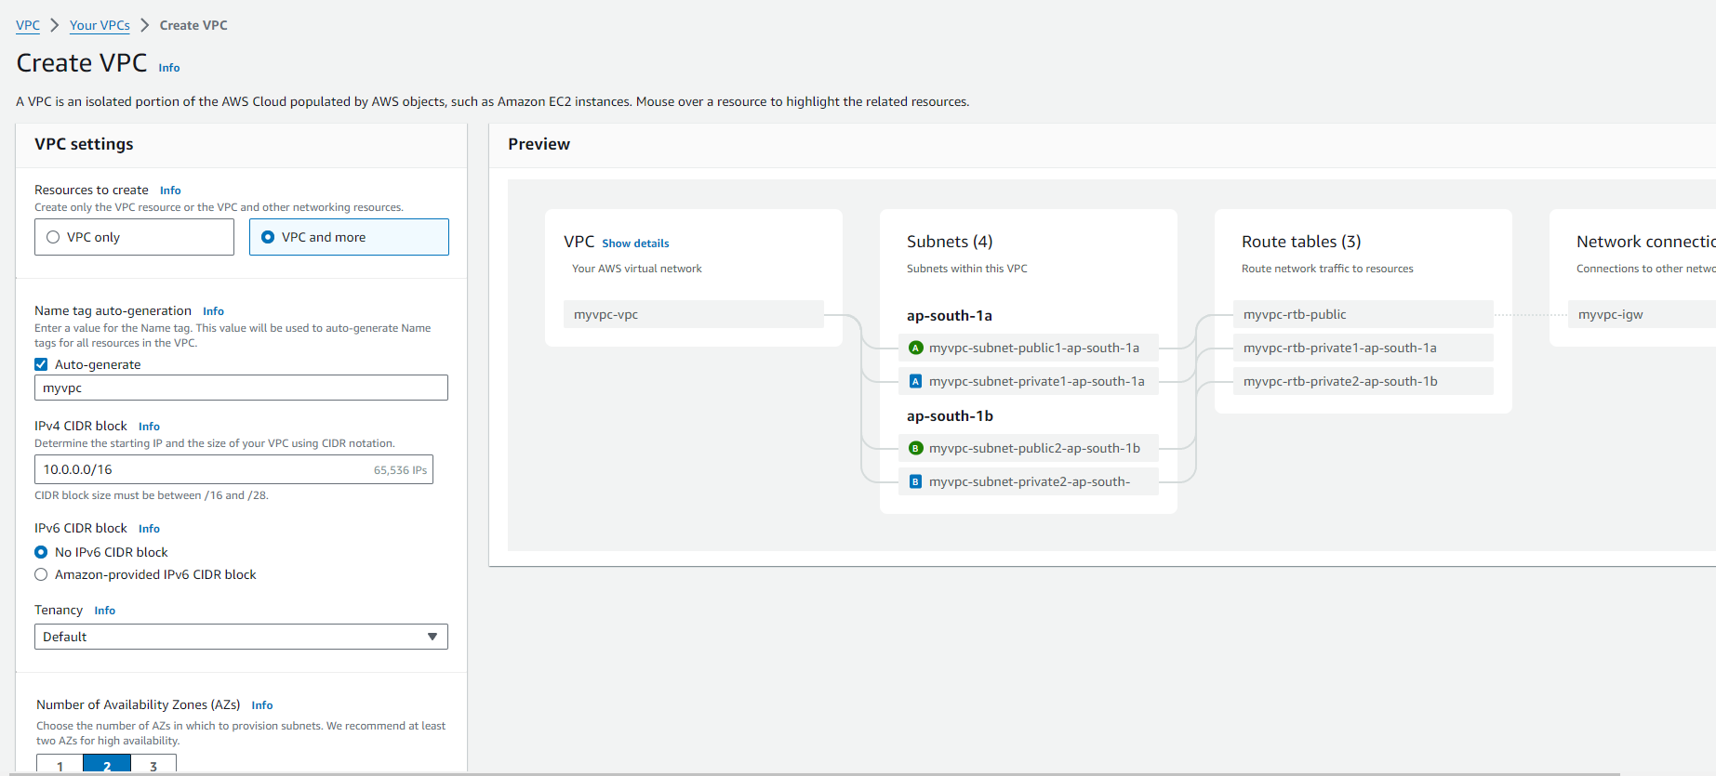

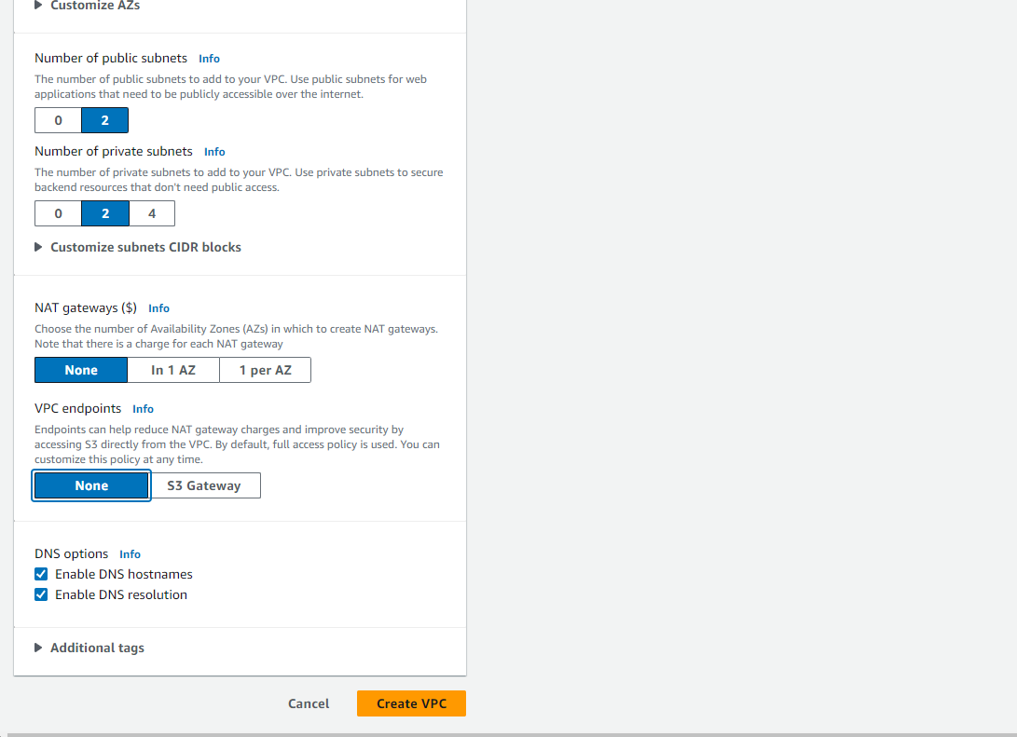

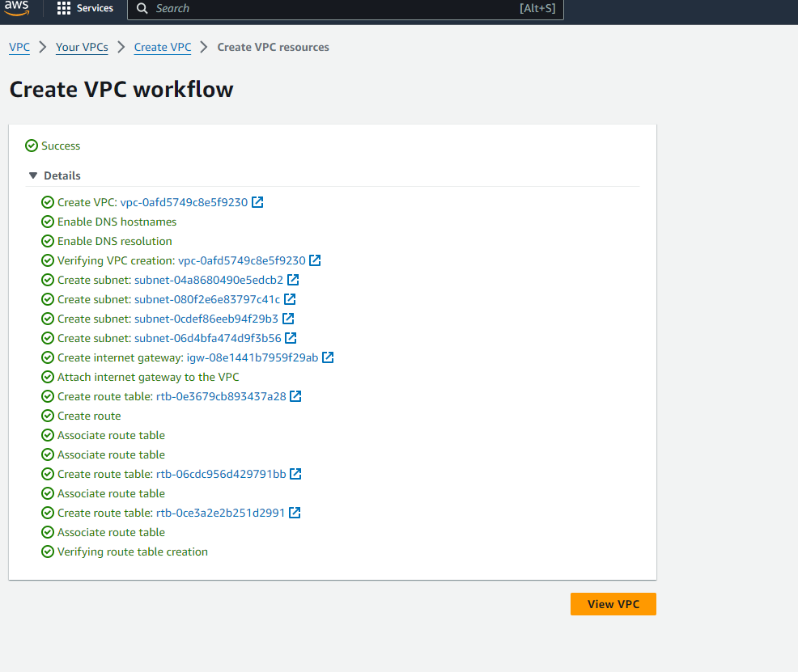

**Created Internet Gateway:**

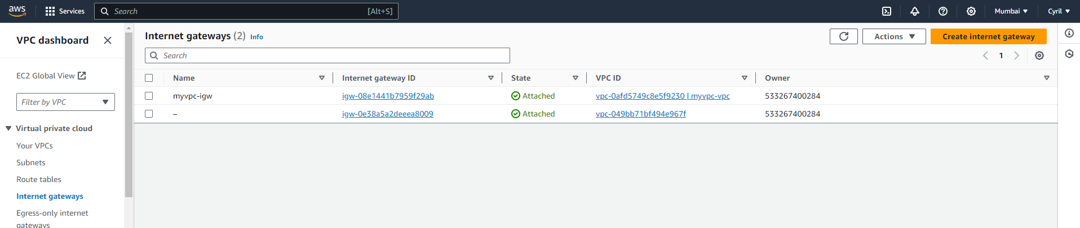

**Public and Private Subnets:**

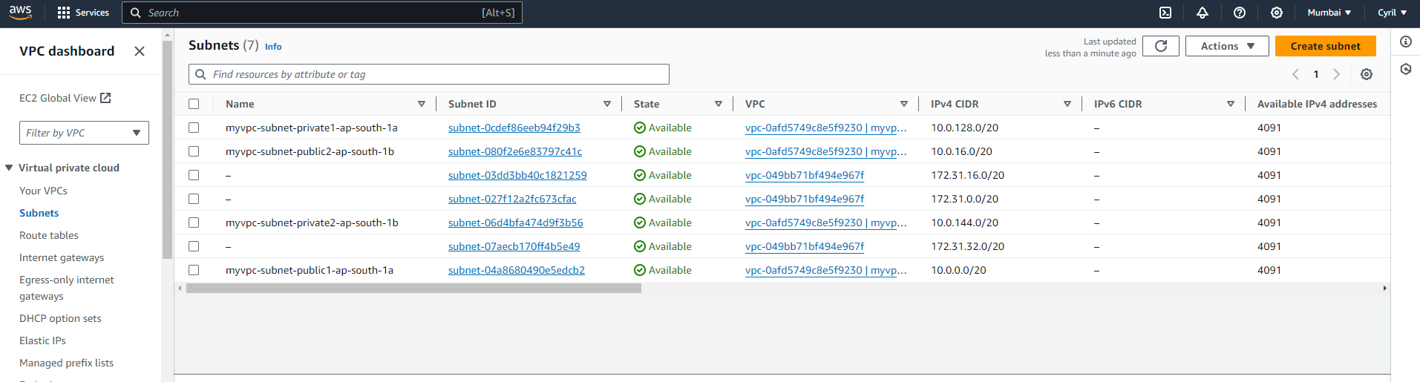

**Route Table:**

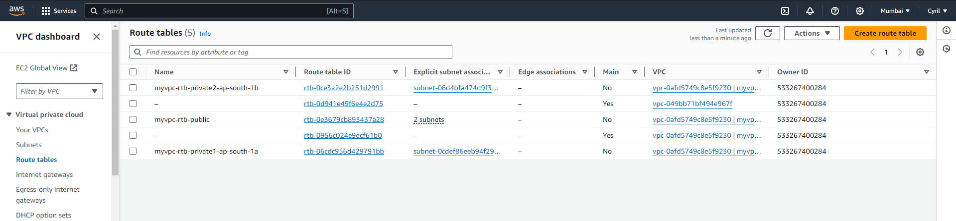

**Creating a EC2 instance using the created VPC and public subnet:**

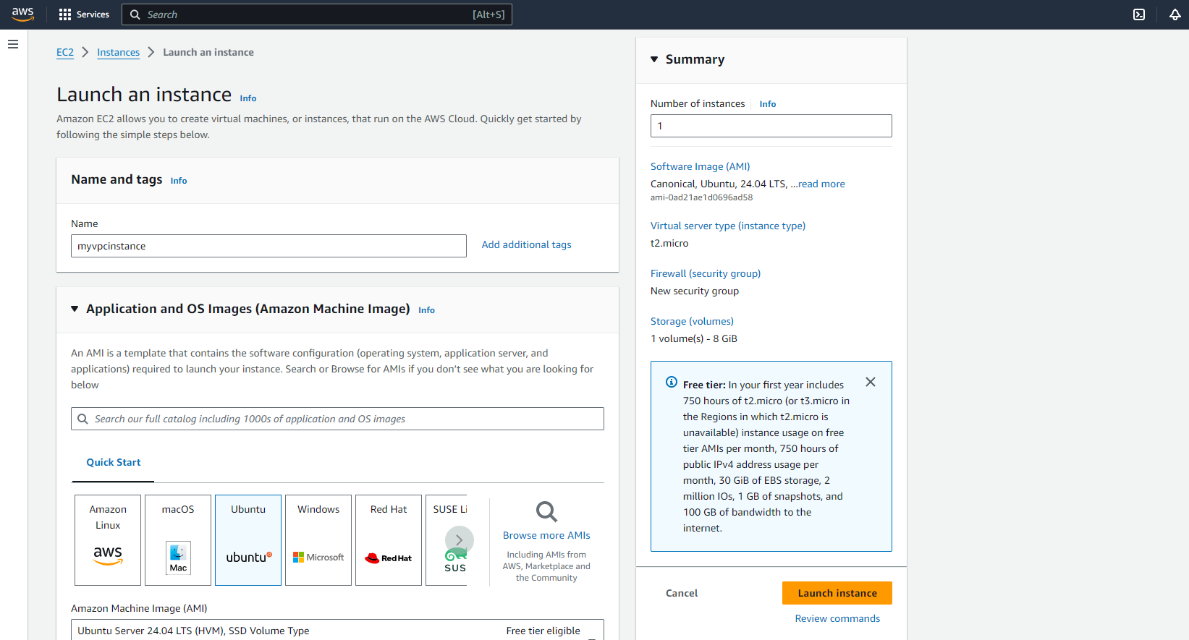

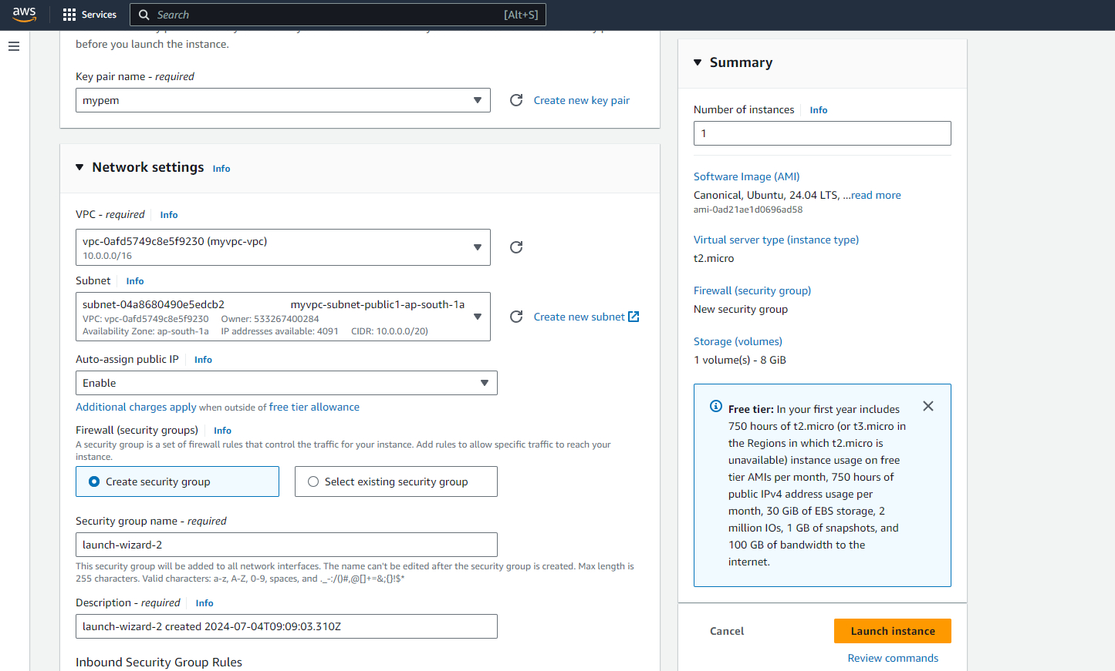

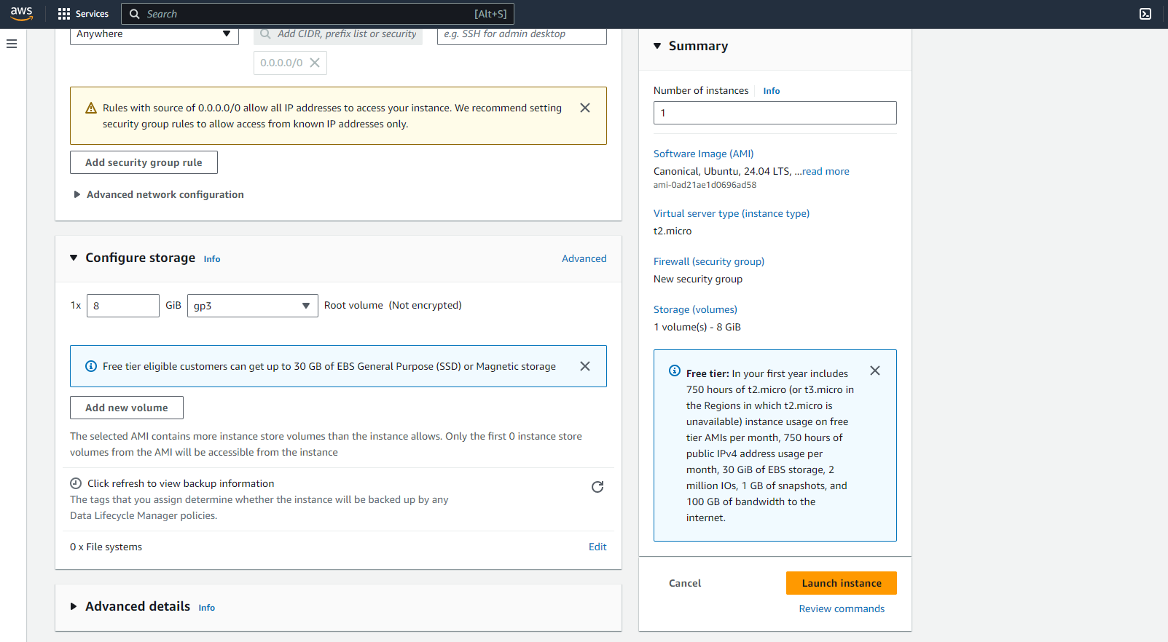

**Connecting remotely to the Created Instance:**

